Where’s the Gap?

Exploring the Gender Pay Gap in the UK

# Introduction

The gender pay gap is the difference between the median hourly wage of men and women, commonly expressed as a percentage of the median hourly wage of men. Legally, employers are required to pay male and female employees who do the same job the same hourly pay (*Equality Act, 2010*). However, the existence of a positive gender pay gap in the UK workforce indicates that, on average, female workers earn less than their male counterparts.

The gender pay gap of all employees in the UK has decreased from 27.5% in 1997 to 17.3% in 2019 (Office for National Statistics, 2019). However, the annual decrease has varied from -2.2% to +0.6%, and the gender pay gap differs between all workers, part-time workers, and full-time workers.

The UK’s gender pay gap was investigated using data from the Office for National Statistics (ONS) and from the Gender Pay Gap Service, with the goal of identifying patterns and bottlenecks affecting it and investigating possible reasons why it exists. The results of the investigation could be used to inform future policies that would lead to a narrowing of the gender pay gap.

It was hypothesised that the gender pay gap would vary with worker age – with the gap being wider among older workers than younger workers. This was expected because female workers are more likely to take time out of work following childbirth, and to take on more childcare and other caring duties than male workers. The hypothesis that older workers experience a wider gender pay gap than younger workers could also reflect changing attitudes towards women in the workplace across the generations, with older workers entering the workforce at a time when more people expected women to focus on family over career.

It was also hypothesised that there would be a wider gender pay gap in traditionally male-dominated industries, such as IT, construction and finance. This expectation would also be reflected by a wider gender pay gap appearing in large cities such as London, where these industries are more prominent than in rural areas.

# Materials and methods

Several datasets were used to examine the gender pay gap. All tables referenced in this section can be found in Appendix 1.

For an overview of temporal variation in median hourly pay for male and female workers, the *New Earnings Survey (NES) and Annual Survey of Hours and Earnings (ASHE) gender pay gap time series* was obtained from the Office for National Statistics (Office for National Statistics, 2019). This data was acquired in the form of a table as shown in Table 1.

This data was entered into Gapminder Tools Offline (Stiftelsen Gapminder, 2019) to produce an animated time series as shown in Figure 4 (Results section). For some years, two different values were included in the data. In each of these cases the second value was used, because the advisory notes suggested the second value was acquired using a methodology that allowed for comparison to the following year.

## Gender Pay Gap Service

The Gender Pay Gap Service (Gender Pay Gap Service, 2019) provides data submitted by organisations about the gender pay gap within each organisation. The 2018-2019 dataset was acquired from the Gender Pay Gap Service because it is the most recent complete dataset available. It comprises submissions from 10812 companies with the column headings as shown in Table 2.

Only companies with more than 250 employees were required to submit data, but data had been submitted by smaller companies. This introduced the possibility of bias – as companies might be more likely to voluntarily submit if their gender pay gaps were small – so the dataset was filtered using R to remove the data from companies with fewer than 250 employees.

The data contains information about the proportion of each pay quartile that comprises female workers. This metric is a useful indicator of the gender pay gap that gives a more complete overview of the spread of wages across an organisation than differences in median hourly wage.

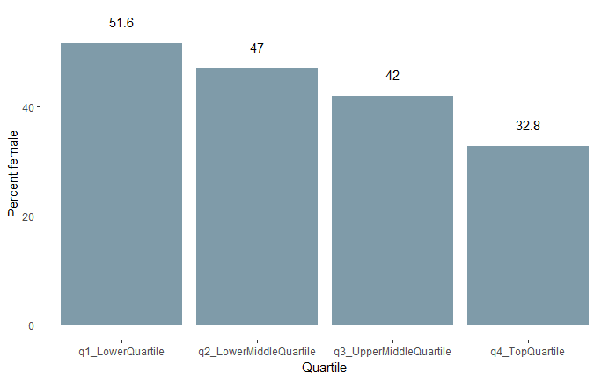The columns relating to pay quartile proportions (FemaleLowerQuartile, FemaleLowerMiddleQuartile, FemaleUpperMiddleQuartile and FemaleTopQuartile in Table 2), were selected and summarised using R to find the median percentage of the workers in each pay quartile that are female. The results of this analysis were displayed using the *ggplot2* package (Wickham, et al., 2019) as shown in Figure 1.

Figure 1 Percentage of pay quartiles comprising female workers, from the Gender Pay Gap Service data

The figures shown in Figure 1 were transferred to Visme (Visme, 2019) to produce a visualisation of the median percentage of workers in each quartile that are female.

## Office for National Statistics Gender Pay Gap Report

The revised 2019 gender pay gap data from the Office for National Statistics (Office for National Statistics, 2019) is compiled from the Annual Survey of Hours and Earnings. Within this dataset are several tables of data, as listed in Table 3 (Appendix 1).

In order to test the hypotheses, the following tables were examined:

* Sic07 Age by Industry (2) SIC2007 Table 21.12
* Home Geography Table 8.12

‘Sic07 Age by Industry (2) SIC2007 Table 21.12’ contains aggregate data for the median and mean gender pay gap for six worker age groups (18-21, 22-29, 30-39, 40-49, 50-59 and 60+) and these same age groups grouped by industry. A large portion of the data available for part-time workers was either unavailable or labelled as unreliable, so only data for full-time workers was considered. The first twenty rows of the table are shown in Table 4 (Appendix 1). The table was imported into R Studio (R Studio, 2019) and filtered to include only the high-level, aggregate industries (those with an alphabetic code). The ‘description’ column was separated into age groups and industries to produce a table with four columns (Age_range, Industry, GPG_median, GPG_mean) as shown in Table 5 (Appendix 1 – first twenty rows only).

Although both median and mean values were supplied, the median was selected for visualisation because it is less likely to be skewed by outliers.

Table 5 was imported into an R shiny application (R Studio, 2019) to produce an interactive chart for use in the storyboard, as shown in Figure 8 (Results section). The data was filtered to include only those industries for which data was available across all age groups, and a slider was added so that the chart would display the gender pay gap across all industries for the age group selected by the slider.

Table 5 was also pivoted using R to produce a table in which each row contained the median gender pay gap for each age group for one industry. Several rows of this table were selected and used to produce a visualisation for the infographic (Figure 7 in the Results section). Selection of industries was based on displaying a representative spread of patterns observed in the gender pay gap.

‘Home Geography Table 8.12’ contained a list of the councils of Britain[1] and the corresponding mean and median gender pay gap for all workers (full-time and part-time) living within their boundaries. This data was manually entered into Visme’s maps tool (Visme, 2019) to produce a chloropleth chart displaying the gender pay gap across Britain for use on the infographic.

## Design of the storyboard

The storyboard was designed to give an overview of the gender pay gap, focusing particularly on the differences in the gender pay gap between part-time and full-time workers and between different age groups and industries.

The interactive charts used in the storyboard were embedded into a story map cascade (Esri, 2019).

The R shiny app demonstrated the pattern that appeared across all industries. The axes were fixed in place to allow for easy comparison between one age group and the next. Data labels were not included, as they would have distracted from the overall trend, but an x-axis was included and the columns were colour-coded so that it was clear when the gender pay gap differed from 0 by more than 5%.

The images surrounding the interactive charts were chosen to have a consistent, muted colour scheme and to be evocative of the subject matter at each stage of the story. Text was minimal so as not to distract from the verbal component.

## Design of the infographic

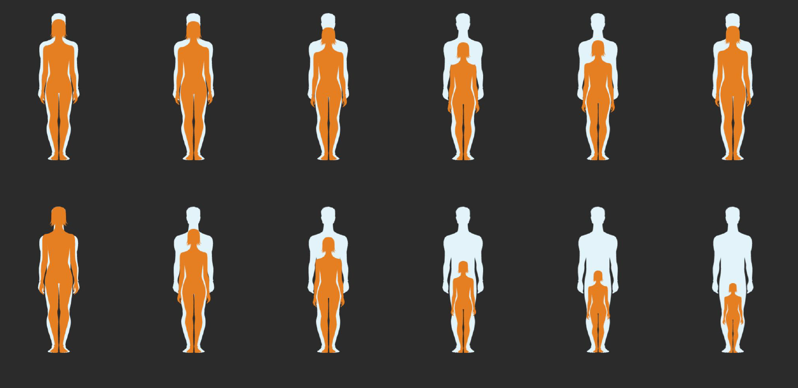The central chart of the infographic, created manually using Visme (Visme, 2019), visually represents the data shown in Table 5, where the percentage height difference between the orange (female) and white (male) icons equals the percentage difference in median pay for those genders (Figure 2). In designing this chart, preattentive attributes, as described by Nussbaumer Knaflic (2015, p. 100), were leveraged to display the gender pay gap as a visual gap between the two icons.

Figure 2leveraging contrast and position to direct viewers’ eyes to the gender pay gap.

The orange and white colours were used again in the chart representing the female percentage of each pay quartile (Figure 3). This chart was generated using Visme’s in-built ‘stats and figures’ feature.

Figure 3 Use of consistent colour scheme between charts

The colour scheme of the whole infographic was selected to be accessible for colour-blind viewers. Apart from orange, black and white, the colours used were shades of teal, which is complementary to orange, so that the orange highlights would stand out. The orange and teal colours are also distinguishable for people with various types of colour-blindness, as tested using the ‘Colouring for Colour Blindness’ tool (Nichols, 2018).

The charts on the infographic were supplemented with explanatory information and the results of a literature review outlining possible reasons for the gender pay gap. Preattentive attributes such as size, colour, shade and position were leveraged throughout the infographic to highlight important features. Deliberate gaps were left in between each element of the infographic, so that the whole graphic reflected the gaps created in the central visual.

# Results

The results of the analysis were presented as an interactive storyboard and as an infographic. The infographic can be view in Appendix 2, and the interactive storyboard is available at <https://www.arcgis.com/apps/Cascade/index.html?appid=a159f5952f8c4292ba396468d94f14f7>.

## Summary of the gender pay gap

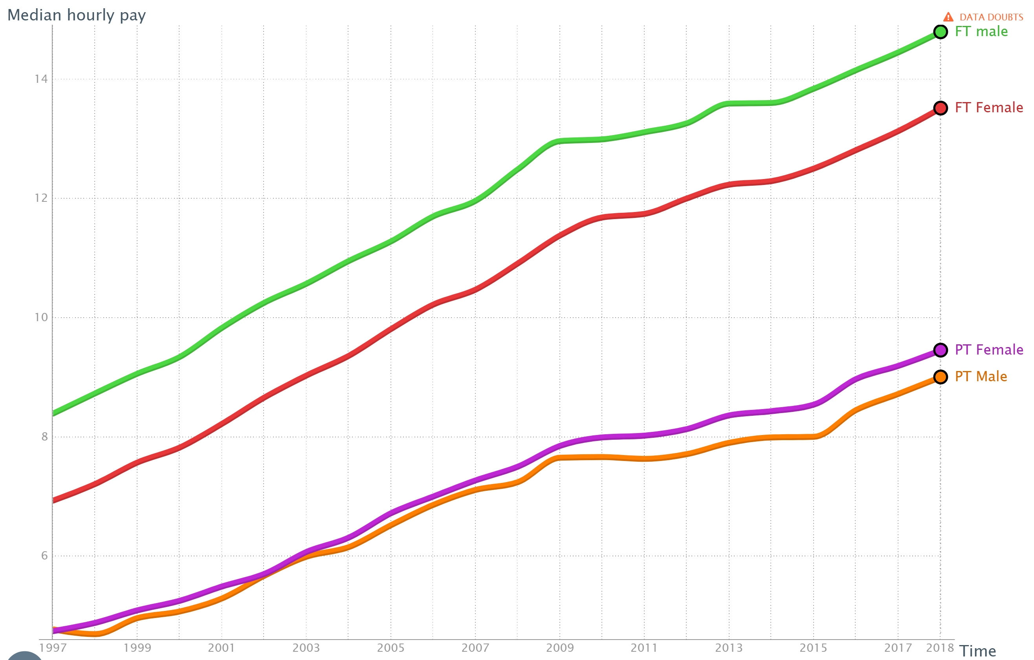Figure 4 shows the time series chart produced using Gapminder. It was displayed as an animation as part of the storyboard.

Figure 4 Time series chart showing change in median hourly pay over time for full-time and part-time male and female workers. FT indicates full-time, PT indicates part-time.

Figure 4 shows that although the median hourly pay of all employed workers in the UK has increased since 1997, among full-time workers there has consistently been a gender pay gap, with full-time male workers being paid around £1 less per hour than full-time female workers. A different pay gap can be seen among part-time workers, and the median hourly pay of female part-time workers has increased at a higher rate than that for male part-time workers since 2009.

Figure 5, from the infographic, shows the gender pay gap for all workers, full-time workers and part-time workers in 2018 across all industries in the UK.

Figure 5 Representations of the gender pay gap across all age groups and industries.

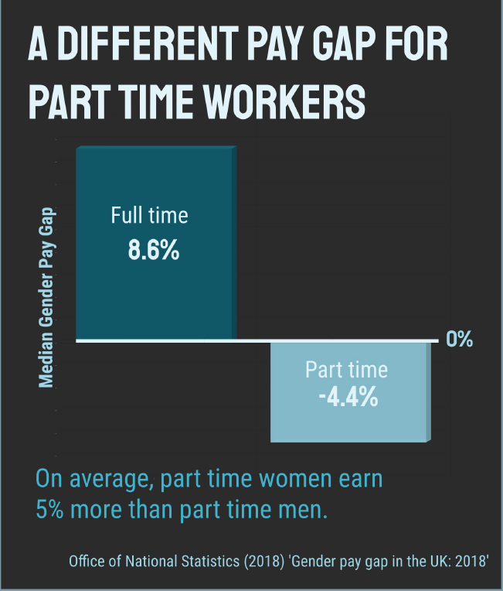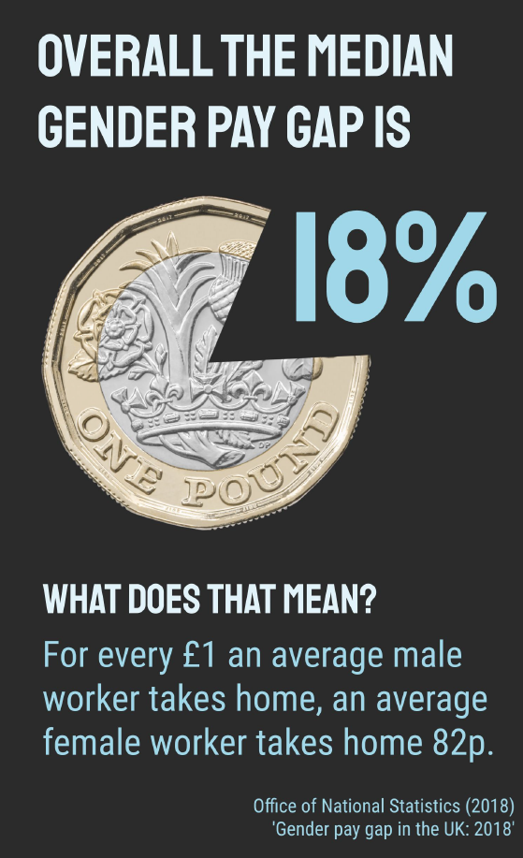

Overall the gender pay gap is 18%, whereas for full-time and part-time workers it is 8.6% and -4.4% respectively. The negative pay gap demonstrates that on average, female part-time workers earn more per hour than male part-time workers.

## The gender pay gap across Britain

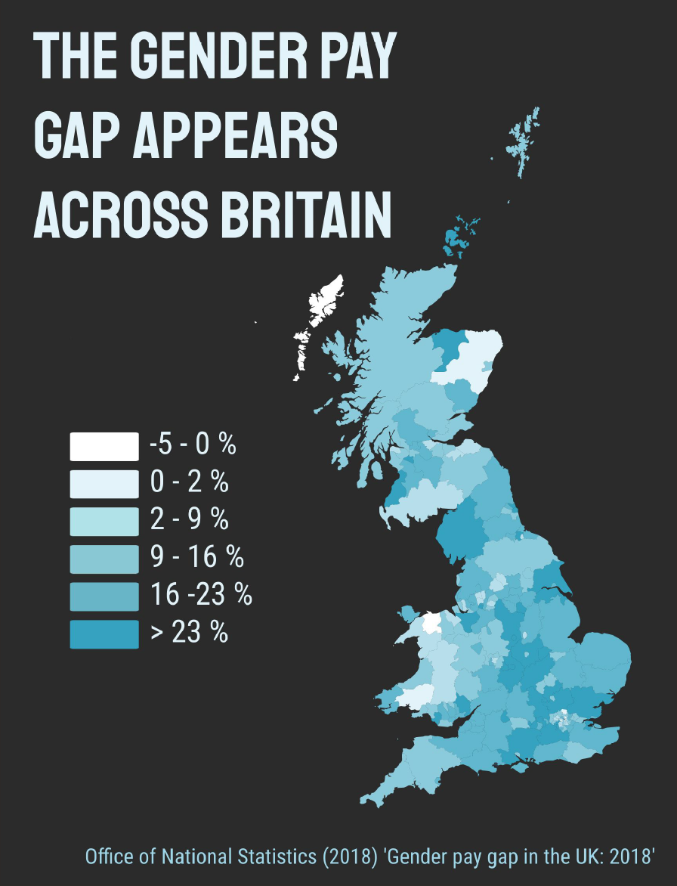Figure 6 is the chloropleth chart created using the data from the Office for National Statistics (2019).

The widest gender pay gap in this dataset was 37.1%, in Wokingham, and the narrowest was 0%, in Hackney. The area with the widest negative gender pay gap is Eilean Siar, where on average female workers earn 4.7% more per hour than male workers.

The chart shows that there is a positive gender pay gap in almost every county of Britain. There appears to be a slight skew towards higher gender pay gap in the south of England, but this may be due to a higher population concentration, and smaller council areas, in that region compared to Scotland and Wales. However, the council area with the narrowest gender pay gap is Hackney, London, so it does not necessarily follow that a denser population leads to a wider gender pay gap.

Figure 6 Chloropleth chart displaying the geographic variation in the gender pay gap. Negative pay gap implies female workers earning more on average than male workers, positive pay gap implies the opposite.

## 

## The variation of gender pay gap with age

Two approaches were taken to visualise the age and industry data. Figure 7 shows the interactive R shiny app used in the storyboard, and Figure 8 shows the icon chart used in the infographic.

Together, these charts indicate that the overall gender pay gap for all industries widens from its minimum value of 1% in the 18-21 age group to its maximum of 26% in the 50-59 age group. This pattern appears across almost all industries, with the gender pay gap among the under-30s in most industries being within ±5% and the gender pay gap among the over 40s in most industries being greater than 10%.

Some industries stand out as exhibiting especially wide gender pay gaps, particularly among older workers. The widest gap observed was a 52.8% difference in median hourly pay between male and female workers aged 60+ in the financial and insurance activities industry.

Some of these results were surprising; in the transportation and storage industry the gender pay gap is within ±5% for all age groups (except for the 18-21 group). This goes against the hypothesis that traditionally male-dominated groups would all exhibit a wider gender pay gap. A possible explanation for this is that there are fewer female workers in front-line jobs in this industry, with more female workers being in managerial, financial and administrative roles.

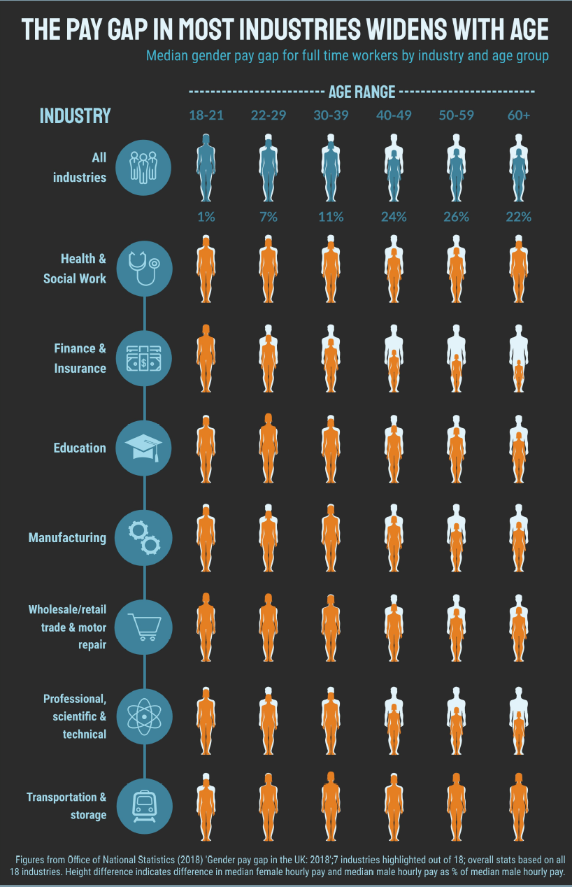

Figure 7 Central chart of the infographic displaying the gender pay gap for six age groups across seven industries as all as aggregate for all industries

Figure 8 Interactive R shiny app allowing for comparison of gender pay gap in different industries between six age groups. Image shows the same chart in two configurations (top: age group = 18-21, bottom: age group = 60+)

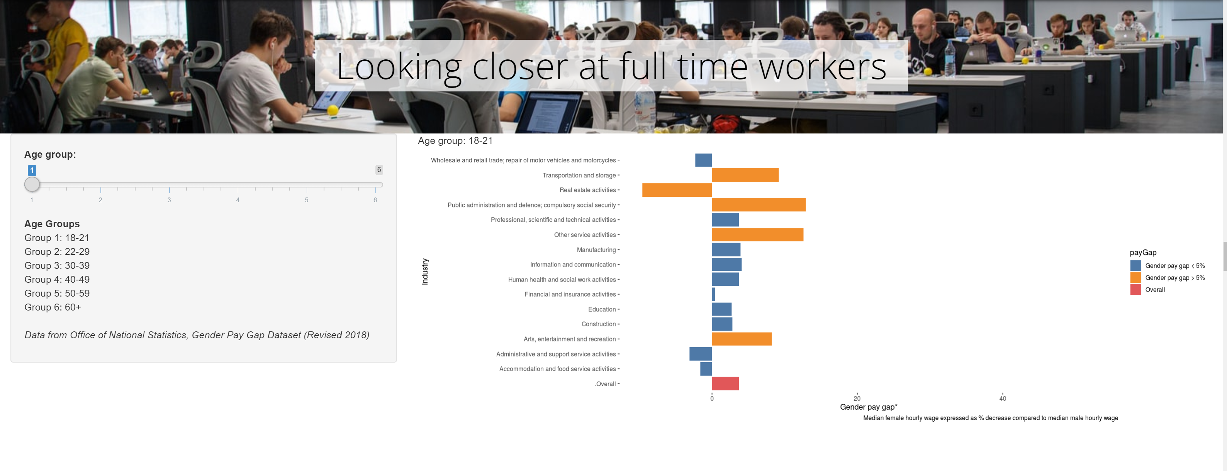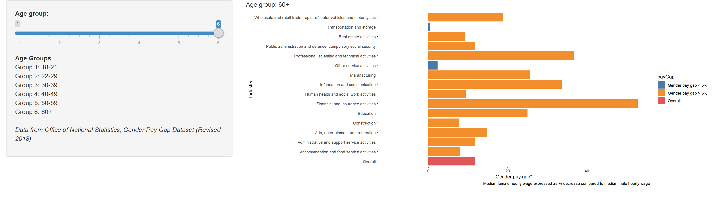

# Discussion

The results demonstrate that, while the gender pay gap has gradually decreased for the UK workforce as a whole, there are still areas of the workforce where female workers are on average paid significantly less than male workers. Most notable of these are women in full-time work over the age of 40.

Possible reasons for this trend are included on the infographic (Appendix 2). Research conducted in Denmark found that a pay gap exists between women who do and do not have children, whereas no such gap exists for men (Kleven, et al., 2018). Since the age at which the gender pay gap in the UK becomes prominent coincides with the decades following typical childbirth age, it seems likely that, as hypothesised, motherhood has an impact on the gender pay gap.

There are many reasons why becoming a parent has a greater impact on female earnings than on male earnings. Taking up to a year off work for maternity leave can lead to missed opportunities for promotions and training, and in some industries technology and working practices will change greatly in a single year, making it difficult to catch up – this may contribute to the especially wide gap for older workers in the financial and insurance industry.

Furthermore, on returning to work mothers tend to work closer to home than fathers (Joyce & Keiller, 2018), presumably to be near to their children. Many women do not return to full time work after having children, which may explain the lack of a gender pay gap among part-time workers; women are more likely than men to cite ‘did not want a full-time job’ as their reason to work part-time (Office for National Statistics, 2019), suggesting that they are more likely to be making a career out of part-time work.

It is not clear from this data what proportion of female workers are satisfied or dissatisfied with the impact that motherhood has had on their earnings, but while this remains unclear steps should be taken to ensure that there are equal *opportunities* for male and female workers to enter the upper pay quartile. These actions include helping parents to make informed choices about childcare responsibilities and to understand the consequences of those choices, encouraging companies to offer flexible and remote work policies to address the gender commuting gap (Joyce & Keiller, 2018), and addressing inequalities in parental leave access. Addressing these areas that can contribute to the gender pay gap would help to establish a culture of choice for parents, as opposed to an inevitable gap for mothers.

# References

Equality Act, c., 2010. London: The Stationery Office.

Esri, 2019. *Story Map Cascade.* [Online]   
Available at: http://storymaps-classic.arcgis.com/en/app-list/cascade/  
[Accessed December 2019].

Gender Pay Gap Service, 2019. *Download gender pay gap data - Reporting year 2018-2019.* [Online]   
Available at: https://gender-pay-gap.service.gov.uk/

Joyce, R. & Keiller, A. N., 2018. *The 'gender commuting gap' widens considerably in the first decade after childbirth.* s.l.:s.n.

Kleven, H., Landais, C. & Søgaard, J. E., 2018. Children and Gender Inequality: Evidence from Denmark. *NBER Working Paper No. 24219.*

Nichols, D., 2018. *Coloring for Colorblindness.* [Online]   
Available at: https://davidmathlogic.com/colorblind  
[Accessed December 2019].

Nussbaumer Knaflic, C., 2015. *Storytelling with Data : A Data Visualization Guide for Business Professionals.* 1 ed. Hoboken, NJ, USA.: John Wiley & Sons, Incorporated.

Office for National Statistics, 2019. *Gender Pay Gap in the UK: 2019.* [Online]   
Available at: https://www.ons.gov.uk/employmentandlabourmarket/peopleinwork/earningsandworkinghours/bulletins/genderpaygapintheuk/2019  
[Accessed October 2019].

Office for National Statistics, 2019. *Labour market economic commentary: November 2019.* [Online]   
Available at: https://www.ons.gov.uk/employmentandlabourmarket/peopleinwork/employmentandemployeetypes/articles/labourmarketeconomiccommentary/november2019  
[Accessed December 2019].

Office for National Statistics, 2019. *New Earnings Survey (NES) and Annual Survey of Hours and Earnings (ASHE) gender pay gap time series.* [Online]   
Available at: https://www.ons.gov.uk/employmentandlabourmarket/peopleinwork/earningsandworkinghours/adhocs/10751newearningssurveynesandannualsurveyofhoursandearningsashegenderpaygaptimeseries  
[Accessed December 2019].

Office for National Statistics, 2019. *ONS Dataset: Gender Pay Gap.* [Online]   
Available at: https://www.ons.gov.uk/employmentandlabourmarket/peopleinwork/earningsandworkinghours/datasets/annualsurveyofhoursandearningsashegenderpaygaptables  
[Accessed December 2019].

R Studio, 2019. *R Studio Software (Version 1.2.1578).* [Online]   
Available at: https://rstudio.com/  
[Accessed December 2019].

R Studio, 2019. *Shiny from R Studio.* [Online]   
Available at: https://shiny.rstudio.com/  
[Accessed December 2019].

Stiftelsen Gapminder, 2019. *Gapminder Offline v5.0.0.* [Online]   
Available at: https://www.gapminder.org/tools-offline/  
[Accessed December 2019].

Visme, 2019. *Free Infographic Software and Presentation Maker.* [Online]   
Available at: visme.co  
[Accessed December 2019].

Wickham, H. et al., 2019. *ggplot2: part of the tidyverse (version 3.2.1).* [Online]   
Available at: https://ggplot2.tidyverse.org/index.html  
[Accessed December 2019].

Wickham, H. et al., 2019. *dplyr: part of the tidyverse (version 0.8.3).* [Online]   
Available at: https://dplyr.tidyverse.org/  
[Accessed 2019].

# Appendix 1: Datasets used in report

|  |  |  |  |  |  |  |  |
| --- | --- | --- | --- | --- | --- | --- | --- |
|  |  | All Workers | | Full Time | | Part Time | |
|  |  | **Male** | **Female** | **Male** | **Female** | **Male** | **Female** |
|  |  | £ | £ | £ | £ | £ | £ |
|  |  |  |  |  |  |  |  |
| 1997 |  | 8.17 | 5.92 | 8.40 | 6.94 | 4.78 | 4.75 |
| 1998 |  | 8.49 | 6.17 | 8.74 | 7.22 | 4.70 | 4.89 |
| 1999 |  | 8.81 | 6.43 | 9.07 | 7.58 | 4.97 | 5.10 |
| 2000 |  | 9.06 | 6.64 | 9.35 | 7.83 | 5.08 | 5.26 |
| 2001 |  | 9.48 | 6.98 | 9.84 | 8.23 | 5.30 | 5.50 |
| 2002 |  | 9.92 | 7.25 | 10.26 | 8.67 | 5.68 | 5.71 |
| 2003 |  | 10.21 | 7.65 | 10.58 | 9.04 | 6.00 | 6.08 |
| 2004a |  | 10.67 | 8.00 | 11.09 | 9.53 | 6.16 | 6.34 |
|  |  |  |  |  |  |  |  |
| 2004b |  | 10.54 | 7.94 | 10.96 | 9.37 | 6.16 | 6.32 |
| 2005 |  | 10.77 | 8.33 | 11.29 | 9.82 | 6.53 | 6.73 |
| 2006c |  | 11.20 | 8.71 | 11.71 | 10.23 | 6.87 | 7.01 |
|  |  |  |  |  |  |  |  |
| 2006d |  | 11.15 | 8.67 | 11.64 | 10.14 | 6.86 | 7.01 |
| 2007 |  | 11.48 | 8.97 | 11.97 | 10.48 | 7.12 | 7.28 |
| 2008 |  | 11.97 | 9.28 | 12.50 | 10.92 | 7.25 | 7.51 |
| 2009 |  | 12.40 | 9.67 | 12.97 | 11.39 | 7.66 | 7.86 |
| 2010 |  | 12.34 | 9.89 | 13.00 | 11.69 | 7.67 | 8.00 |
| 2011e |  | 12.42 | 10.00 | 13.11 | 11.91 | 7.67 | 8.10 |
|  |  |  |  |  |  |  |  |
| 2011f |  | 12.41 | 9.90 | 13.12 | 11.75 | 7.64 | 8.03 |
| 2012 |  | 12.50 | 10.05 | 13.27 | 12.01 | 7.72 | 8.14 |
| 2013 |  | 12.85 | 10.31 | 13.60 | 12.24 | 7.91 | 8.37 |
| 2014 |  | 12.82 | 10.36 | 13.61 | 12.30 | 8.00 | 8.44 |
| 2015 |  | 13.00 | 10.49 | 13.85 | 12.51 | 8.01 | 8.55 |
| 2016 |  | 13.35 | 10.92 | 14.16 | 12.82 | 8.46 | 8.98 |
| 2017 |  | 13.70 | 11.18 | 14.46 | 13.14 | 8.73 | 9.20 |
| 2018 |  | 13.99 | 11.49 | 14.80 | 13.52 | 9.01 | 9.46 |
| 2019 |  | 14.53 | 12.01 | 15.34 | 13.97 | 9.70 | 10.00 |

Table 1 Median gross hourly earnings excluding overtime for full-time and part-time employees in the UK. Data acquired from the Office of National Statistics.

|  |  |
| --- | --- |
| Column Heading | Description (where relevant) |
| EmployerName |  |
| Address |  |
| CompanyNumber |  |
| SicCodes |  |
| DiffMeanHourlyPercent | Difference between mean female hourly pay and mean male hourly pay, expressed as percentage of mean male hourly pay |
| DiffMedianHourlyPercent | Difference between median female hourly pay and median male hourly pay, expressed as percentage of median male hourly pay |
| DiffMeanBonusPercent | Difference between mean female bonus pay and mean male bonus pay, expressed as percentage of mean male bonus pay |
| DiffMedianBonusPercent | Difference between median female bonus pay and median male bonus pay, expressed as percentage of median male bonus pay |
| MaleBonusPercent | Percentage of male workers who received a bonus |
| FemaleBonusPercent | Percentage of female workers who received a bonus |
| MaleLowerQuartile | Percentage of lower pay quartile workers who are male |
| FemaleLowerQuartile | Percentage of lower pay quartile workers who are female |
| MaleLowerMiddleQuartile | Percentage of lower middle pay quartile workers who are male |
| FemaleLowerMiddleQuartile | Percentage of lower middle pay quartile workers who are female |
| MaleUpperMiddleQuartile | Percentage of upper middle pay quartile workers who are male |
| FemaleUpperMiddleQuartile | Percentage of upper middle pay quartile workers who are female |
| MaleTopQuartile | Percentage of top pay quartile workers who are male |
| FemaleTopQuartile | Percentage of top pay quartile workers who are female |
| CompanyLinkToGPGInfo | url of company’s report on their gender pay gap |
| ResponsiblePerson |  |
| EmployerSize | One of: <250, 250 to 499, 500 to 999, 1000 to 4999, 5000 to 19,999 and 20,000 or more |
| CurrentName |  |
| SubmittedAfterTheDeadline | Whether or not the submission was late |
| DueDate |  |
| DateSubmitted |  |

Table 2 Column headings of Gender Pay Gap dataset

|  |
| --- |
| Age by Occupation SOC10 (2) Table 20.12 |
| Age Group Table 6.12 |
| Home Geography Table 8.12 |
| Home LEPS Table 28.12 |
| Home Nuts (3) Table 23.12 |
| Home Parliamentary Constituency Table 10.12 |
| Home Travel To Work Area Table 12.12 |
| Occupation SOC10 (2) Table 2.12 |
| Occupation SOC10 (4) Table 14.12 |
| PubPriv Table 13.12 |
| Sic07 Age by Industry (2) SIC2007 Table 21.12 |
| Sic07 Industry (2) SIC2007 Table 4.12 |
| Sic07 Industry (4) SIC2007 Table 16.12 |
| Sic07 Work Region Industry (2) SIC2007 Table 5.12 |
| Total Table 1.12 |
| Work Geography Table 7.12 |
| Work LEPS Table 27.12 |
| Work Nuts (3) Table 22.12 |
| Work Parliamentary Constituency Table 9.12 |
| Work Region Age Table WGOR Age.12 |
| Work Region Occupation SOC10 (2) Table 3.12 |
| Work Region Occupation SOC10 (4) Table 15.12 |
| Work Region PubPriv Table 25.12 |
| Work Travel To Work Area Table 11.12 |

Table 3 List of tables within ONS gender pay gap dataset

|  |  |  |  |
| --- | --- | --- | --- |
| SIC2007 Table 21.12 Gender pay gap (%)^ - For all employee jobs^^: United Kingdom, 2018 | | | |
|  |  |  |  |
|  |  | **Gender** | **Gender** |
|  |  | **pay gap** | **pay gap** |
| Description | **Code** | **median** | **mean** |
| All employees |  | 17.8 | 17.2 |
| 18-21 |  | 1.1 | 4.8 |
| 22-29 |  | 6.7 | 7.1 |
| 30-39 |  | 11.4 | 10.2 |
| 40-49 |  | 23.5 | 20.4 |
| 50-59 |  | 25.9 | 24.0 |
| 60+ |  | 22.2 | 25.2 |
| 18-21, All Industries and Services |  | 1.1 | 4.7 |
| 18-21, All Index of Production Industries |  | 3.5 | 4.9 |
| 18-21, All Manufacturing |  | 3.1 | 6.3 |
| 18-21, All Service Industries |  | 0.2 | 4.3 |
| 18-21, Agriculture, forestry and fishing | A | 8.3 | 12.8 |
| 18-21, Crop and animal production, hunting and related service activities | 1 | 8.3 | 12.8 |
| 18-21, Forestry and logging | 2 | x | x |
| 18-21, Fishing and aquaculture | 3 | x | x |
| 18-21, Mining and quarrying | B | x | x |
| 18-21, Mining of coal and lignite | 5 | x | x |
| 18-21, Extraction of crude petroleum and natural gas | 6 | x | x |
| 18-21, Mining of metal ores | 7 | x | x |
| 18-21, Other mining and quarrying | 8 | x | x |
| 18-21, Mining support service activities | 9 | x | x |

Table 4 Extract of table 'Sic07 Age by Industry (2) SIC2007 Table 21.12' from the Office for National Statistics Gender Pay Gap Dataset

|  |  |  |  |
| --- | --- | --- | --- |
| Age_range | Industry | GPG_median | GPG_mean |
| 18-21 | Agriculture, forestry and fishing | 6.6 | 13.7 |
| 18-21 | Manufacturing | 3.9 | 6.4 |
| 18-21 | Water supply; sewerage, waste management and remediation activities | -9 | -4.7 |
| 18-21 | Construction | 2.8 | 1.3 |
| 18-21 | Wholesale and retail trade; repair of motor vehicles and motorcycles | -2.3 | -4.4 |
| 18-21 | Transportation and storage | 9.2 | 16.3 |
| 18-21 | Accommodation and food service activities | -1.6 | -0.5 |
| 18-21 | Information and communication | 4.1 | 6.8 |
| 18-21 | Financial and insurance activities | 0.4 | 1.9 |
| 18-21 | Real estate activities | -9.6 | -10.5 |
| 18-21 | Professional, scientific and technical activities | 3.7 | 2.4 |
| 18-21 | Administrative and support service activities | -3.1 | -0.9 |
| 18-21 | Public administration and defence; compulsory social security | 12.9 | 10.7 |
| 18-21 | Education | 2.7 | -2.2 |
| 18-21 | Human health and social work activities | 3.7 | 4.1 |
| 18-21 | Arts, entertainment and recreation | 8.2 | 52 |
| 18-21 | Other service activities | 12.6 | 8.1 |
| 22-29 | Agriculture, forestry and fishing | 3.6 | -5.1 |
| 22-29 | Manufacturing | 10.3 | 6.8 |
| 22-29 | Electricity, gas, steam and air conditioning supply | 15.3 | 17.4 |

Table 5 Extract of transformed table for use in visualisations

# Appendix 2: Infographic

Figure 9 Infographic

1. There was no data available for Northern Ireland so a map of the whole of the UK could not be produced.